# INSTITUTE OF BUSINESS ADMINISTRATION (IBA), KARACHI

**INTERNATIONAL RESOURCE CENTRE (IRC)**

IBA INCOMING STUDENT EXCHANGE PROGRAM 2023

The International Resource Center (IRC) at the Institute of Business Administration (IBA), Karachi provides opportunities to students to extend their learning by complementing their academic experience with international exposure. The IRC team coordinates, collaborates, and partners with international universities to offer students exchange opportunities to experience globalized classroom content, develop employability and transferable skills, and expand international and cultural networks. The IRC also assists students who are looking for financial assistance and scholarships and offers a range of services to facilitate and support students in going abroad for summer and semester exchange programs, conferences, international competitions, and more.

The IRC at IBA invites students, professionals, and academics from diverse fields to come forward and learn, conduct research, and be a part of the diverse IBA community. IRC promotes international academic excellence by strengthening transnational education, student, faculty, and staff exchanges and linkages, international student recruitment, research and entrepreneurship collaborations.

The IBA IRC offers opportunities through exchange and study abroad programs with its partner institutions and other international universities.

# THE STUDY ABROAD ADVANTAGE

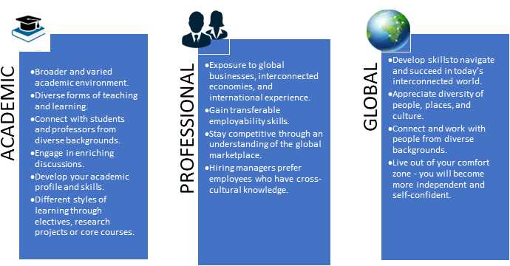

**Gain exposure to diverse cultures and perspectives, and connect with global networks!**

Students from outside Pakistan who would like to spend part of their degree at the Institute of Business Administration, Karachi may do so through the IBA IRC. International Exchange is designed for undergraduates from our partner universities who wish to spend a period of time studying in Pakistan, and earn credits to transfer back to their home university. These students will learn in the regular undergraduate, graduate programs, or short courses in the summer, and study alongside Pakistan-based home students.

Courses are available in all three Schools and across most Programs at the IBA. For more information on the IBA schools and their programs, please visit: <https://www.iba.edu.pk/schools.php>

We would like to invite students from Home University to study at the Institute of Business Administration (IBA) Karachi and become part of an engaging and diverse student experience at IBA.

## ELIGIBILITY CRITERIA

**English Language Proficiency**

* If the exchange/visiting student is applying from a home country/university where English is not the official language or medium of instruction, the student must submit evidence of English Language Proficiency.
* To verify that the medium of instruction is English, the home university can issue an English Proficiency Certificate on its official letterhead. Students are required to provide details of the Program and University applied for, and City and Country of the university.

## Academic Criteria

* All exchange/visiting applicants must be current students at an overseas university or college of higher education. **They must have completed at least one year (two semesters) of study at their home university when they visit IBA. Students enrolled in their last year of the degree program would not be eligible to apply for the semester exchange program. However, they can apply for the Short Course.**

## The minimum academic CGPA requirement is 3.0.

**HOW TO APPLY**

Once a student has been nominated by the home university, the home university representative must complete the Online Exchange Nomination Form: <https://forms.gle/g4sqjXhQ3fJPGL1h6>

Nominated students by the Home University will be contacted by IBA IRC team to submit the Exchange Program Online Application Form separately.

## Before applying to an online application form, students need to make sure that the following documents are ready:

* + A scanned copy of the student’s most recent official transcript
  + A scanned copy of the English Proficiency Certificate/Letter
  + A letter from the home university confirming the student’s nomination
  + A scanned copy of the passport (Valid for at least 18 months)
  + A high-resolution photograph

***All documents must be uploaded on the following Online Exchange Student Form which will be shared with the students separately.***

**Please Note:** Only complete applications will be considered.

It is the student’s responsibility to ensure that their online application is complete. Any delays due to missing/incorrect supporting documents may result in IBA being unable to process your application and provide an offer.

## VISA REQUIREMENTS

To apply for a student visa for Pakistan, please visit the official Pakistan Embassy NADRA pages for all details and documentation.

For more information about the exchange/visiting students visa process, please visit: <https://visa.nadra.gov.pk/student-visa/>

## ACCOMMODATION

Accommodation for a semester (for the Semester exchange), for 6 weeks (for summer exchange), and for a short stay (for short courses) will be borne by IBA and will be free of charge for the exchange/visiting student till the duration that the course/semester lasts.

IBA transportation to and from the IBA Campus is free for all exchange/visiting.

At IBA, we foster a culture of diversity and inclusivity - Our accommodations and facilities ensure that the student feels at home and is part of a safe, welcoming, and sociable community.

## TUITION FEE

International exchange students are exempt from paying any tuition fees to IBA Karachi provided there is a current exchange agreement in place between IBA and the home university.

## TERMS AND CONDITIONS OF THE EXCHANGE OFFER

* **Each School can accommodate up to five students in the Undergraduate Programs, and up to two students in the Masters Programs. The list of programs can be accessed here:** [**https://www.iba.edu.pk/schools.php**](https://www.iba.edu.pk/schools.php)
* Most exchange/visiting students can select a range of courses of their choice at IBA, provided they get prior approval from their Home University. They can check the program-wise list of courses provided by the IBA Karachi in the following link: [https://www.iba.edu.pk/News/pa-2022-23.pdf.](https://www.iba.edu.pk/News/pa-2022-23.pdf) Moreover, the list of courses offered in the said semester would be shared with the nominated students, separately.
* Exchange students may choose a combination of courses for which their credits will be transferred, or courses that will not be eligible for credit transfer – the choice is theirs. However, it is advised that the majority of courses taken should be equivalent to their home academic school/program, but students can also choose courses from other schools/departments.
* Students must be formally nominated to study at IBA by their Home University. The students can be shortlisted by Home University based on their interview process or other criteria.
* International exchange students are exempt from paying any tuition fees to IBA Karachi - they will study at the IBA free of charge.
* A student can only come for one semester or summer. She/he cannot come for the next semester, as we would like new students to come in each semester or summer to avail the exchange program. However, a student is eligible to apply again after one year.
* Airfare, travel insurance, visa fee, and stipend will be borne by Home University.
* Accommodation will be borne by IBA.
* Transportation costs to and from the student residences to campus will be provided by IBA.
* The visiting students will have access to all the Centers at IBA. Following is the list of Centers:
  + AMAN Center for Entrepreneurial Development (CED): <https://ced.iba.edu.pk/>
  + Center for Excellence in Journalism (CEJ): <https://cej.iba.edu.pk/>
  + Centre for Excellence in Islamic Finance (CEIF): <https://ceif.iba.edu.pk/>
  + Karachi Urban Lab (KUL): <http://karachiurbanlab.com/>
  + Center for information and Communication Technology (CICT): <https://cict.iba.edu.pk/>
* Academic and advisory services to the visiting students will be provided by IBA (meetings with Academic Counselors, Faculty, and others).
* Exchange/Visiting students will have access to the Student Center and all sports facilities.
* Karachi City Tours will be organized for all exchange/visiting students.

Looking forward to an engaging and diverse student experience at IBA! For details, reach out to IBA IRC: [internationaloffice@iba.edu.pk](mailto:internationaloffice@iba.edu.pk)